First of all I set the working directory to homework directory with setwd(….) function. Defined safe log to avoid getting errors if for log(0) values. By using read.csv function I read the images set and labels set. As it is told in the pdf I split the images dataset into training and testing sets. For the fourth question I followed the following lecture note
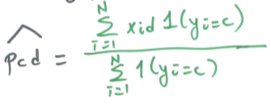
I calculated the pcd value for each class (A,B,C,D,E) and column bind each of these values in a matrix called pcd. By calling pcd[,1] I would get the pcd values of A.
Then I implemented the score functions for each class (A,B,C,D,E) using the corresponding pcd value. By comparing the score function values I can decide which class my data belongs.
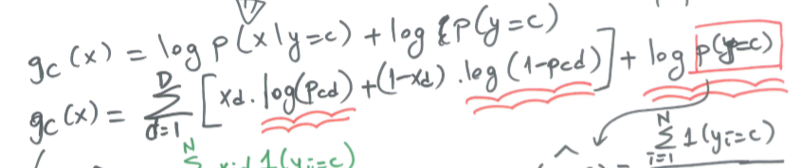
I stored the class score values for each pcd value and then found the maximum element of each row. By comparing the maximum element of each row to score functions using different pcd values I created the confusion matrix. I simply followed the same method for the last question but instead of appliying the score funtion to training set I applied it to the testing set and built the confusion matrix the same way.
Detailed description of my homework is in the code file as comments.

